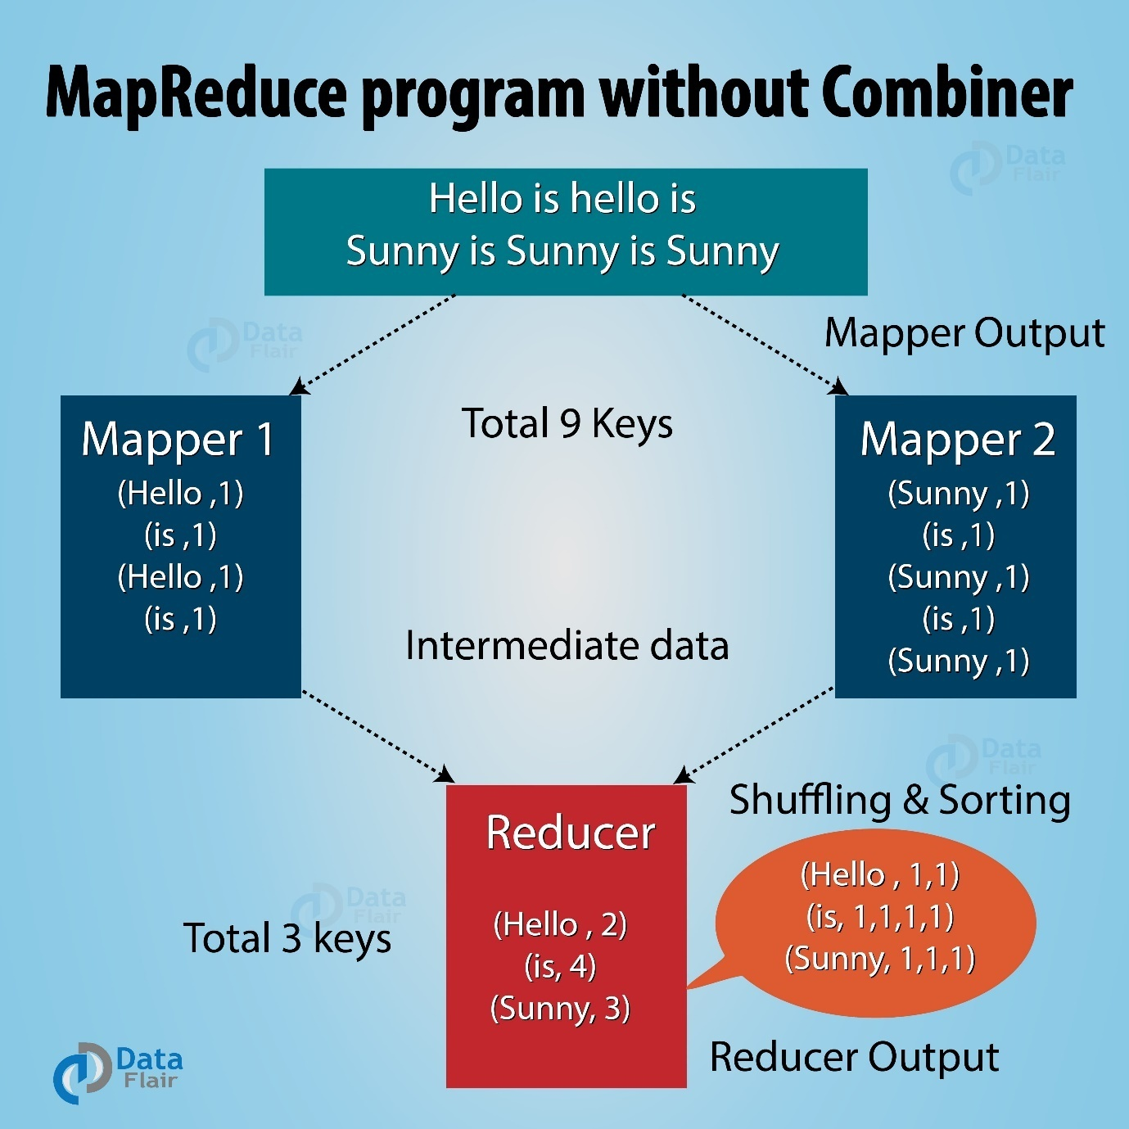

Combiner
- Also known as mini reducer
- It is an optional phase after mapper and before reducer
- Minimizes the time taken for the data transfer between the mapper and reducer
- To reduce the amount of data transfer over network.
Need of combiner
- To overcome Network Congestion problem
If there are many key value pairs generated by the mappers, these pairs should be traversed through the network to the reducer for further processing as a result network may get congested.
- To improve overall performance of Reducer
Decreases the amount of data needed to be processed by reducers.
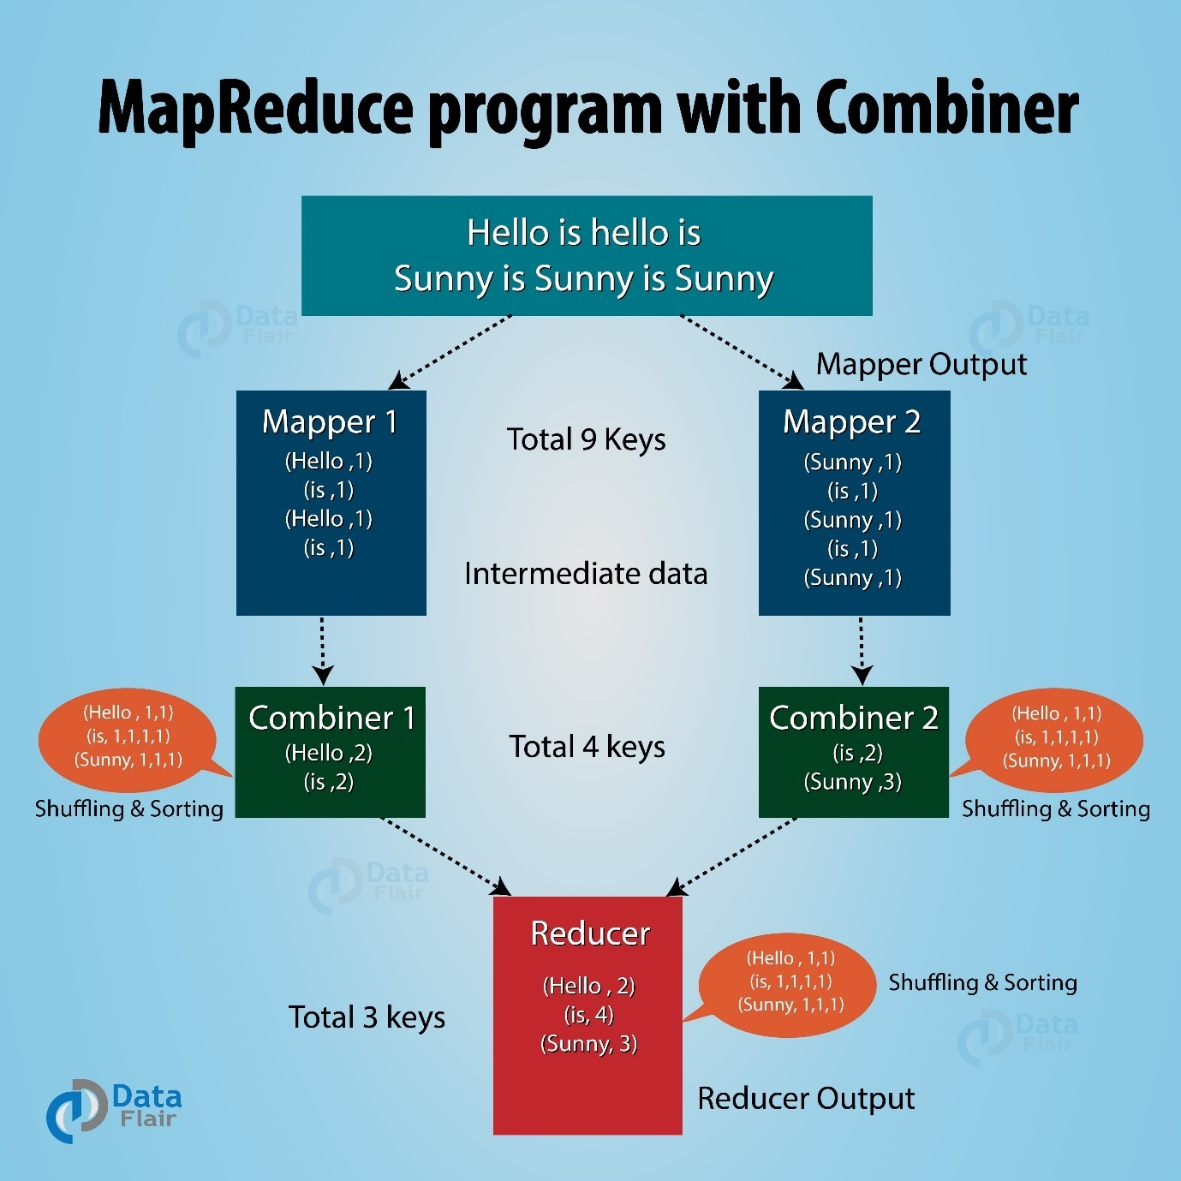

Partitioner
- It is an optional phase after combiner and before reducer
- It takes the decision that which key goes to which reducer by using hash function
- All the records having the same key must be sent to the same reducer
- No. of partitions = no. of reducers
- Hadoop Partitioning specifies that all the values for each key are grouped together. It also makes sure that all the values of a single key go to the same reducer. This allows even distribution of the map output over the reducer.
- Partitioner in a MapReduce job redirects the mapper output to the reducer by determining which reducer handles the particular key.
- JobConf.setNumReduceTasks()

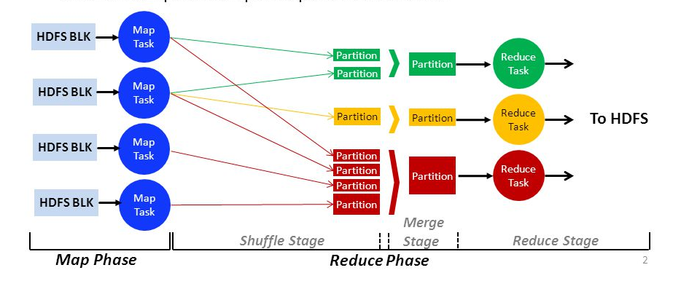

How the number of partitions isdecided?
The total number of Partitioner depends on the number of reducers. Hadoop Partitioner divides the data according to the number of reducers.Hadoop decides it at the time when the map reduce job starts that how may partitions will be there which is controlled by the JobConf.setNumReduceTasks()method.
What is happening by default?
By default the partitioner implementation is called HashPartitioner. It uses the hashCode() method of the key objects modulo the number of partitions total to determine which partition to send a given (key, value) pair to.
A Custom Partitioner can be written by overriding the getPartition method. The getPartition method takes two parameters which is the key and value.

The getPartition() method takes a <K,V> pair and the number of partitions to split the data, a number in the range [0, numPartitions) must be returned by this method,indicating which partition to send the key and value
Example: Our custom partitioner will send all <K,V> by Gender Male to one partition and <K,V> with Female to other partition .
public static class MyPartitioner extends Partitioner<Text,Text>{
public int getPartition(Text key, Text value, int numReduceTasks){
if(numReduceTasks==0)
return 0;
if(key.equals(new Text(“Male”)) )
return 0;
if(key.equals(new Text(“Female”)))
return 1;
}
}
Here , the getPartition() will return 0 if the key is Male and 1 if key is Female.
We can check our output in two files:
part-r-0000 and part-r-0001.

